**LEBANESE AMERICAN UNIVERSITY**

**USAID – HIGHER EDUCATION SCHOLARSHIP PROGRAM**

**HES - Volunteering Program Verification Form**

This form is to be used to document volunteering hours. If a student volunteers for multiple organizations, a separate form must be used for each organization. **This form must be turned in by the 28th of each month, the latest.**

I certify that the scholar Malak Saleh El-issa completed a total of 5 hours of service at Life Sculptor.

The hours were completed hours as per the below:

Hours # 0 (date) _02/09 - 06/09_ (initials of supervisor) __A.K.___

Hours # 0 (date) _09/09 – 13/09_ (initials of supervisor) __A.K.___

Hours # 0 date) _16/09 – 20/09 (initials of supervisor) __A.K.___

Hours # 5 date) _23/09 – 27/09 (initials of supervisor) __A.K.___

Brief description of the activities the scholar performed or participated in:

I work on the topic of Expanding Arab League’s Relations with International Organizations . I start with introduction to the topic ( overview of the topic ,purpose of the committee discussion , and key questions for delegates ) . Then , I start with the introduction to the Arab league (History of the Arab league , current role and objectives , and recent diplomatic initiatives ) . After that I search about key international organizations such as ; BRICS ( potential benefits and challenges when collaborate with the Arab league ) , Group of seven(introduction to it and cooperation areas) , ASEAN , OAS,AU and EU . Then, I start with the potential areas of cooperation ( economic integration , security and counterterrorism, political and diplomatic alliances , social development and human right , environmental sustainability ) . Moreover, I work on challenges and barriers to expanding relations ( political disparities , economic disparities and competing interests , regional instability and conflicts, diplomatic and legal hurdles) . After that , I search about case studies on existing partnerships between Arab leagues and international organizations like the EU and AU and the lessons learned and on success stories . Finally , the conclusion I recap the potential benefits of expanding the Arab Leagueʼs relations with international organizations and Offer final thoughts on how the Arab League should prioritize and approach these international partnerships. Suggestions for how delegates can move forward with discussions on this top.

Written feedback about the scholar’s performance:

Malak demonstrated strong research and analytical skills by thoroughly exploring the Arab League’s relations with international organizations. She examined the League’s history, key global partnerships, and potential areas for cooperation in economic, political, and social spheres. Her work also addressed challenges, case studies, and successful collaborations, showcasing her ability to analyze complex issues and offer practical insights. Malak’s structured approach and comprehensive understanding of international diplomacy highlight her expertise in global relations.

Please rate the overall performance of the scholar at your organization:

|  |  |  |  |
| --- | --- | --- | --- |
|  | Mastery (5) | Proficient (3) | Emerging (1) |
| **Problem solver** | X |  |  |
| **Engaged & Committed** | X |  |  |
| **Open-minded & multicultural** | X |  |  |

Signature

& stamp

__________________________

_

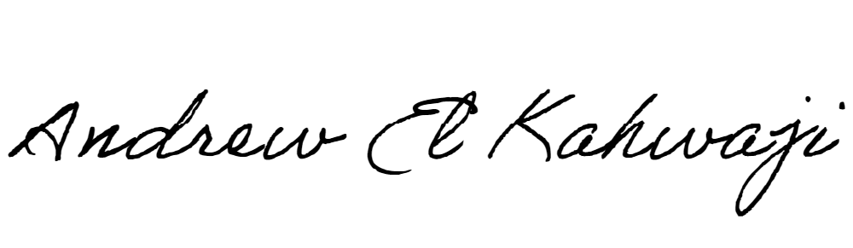

Printed Name _Andrew El Kahwaji_

Date __25/09/2024___

Email __andrew.lifesculptor.coo@gmail.com __

Phone __+961 71 914 378__

**LEBANESE AMERICAN UNIVERSITY**

**USAID – HIGHER EDUCATION SCHOLARSHIP PROGRAM**

